

Job role: Underwriting Manager

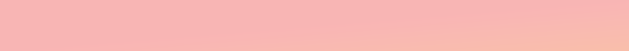
Band: Senior Management
Responsible to: Chief Legal & Lending Officer

Department: Underwriting

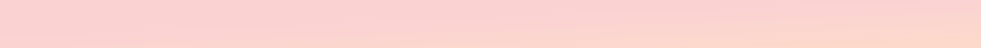
PURPOSE

Reporting directly to the Chief Lending & Legal Officer, the role holder is responsible for the effective running of the Society’s Underwriting Department and assessment of loan applications across the Society’s mortgage book within risk appetite.

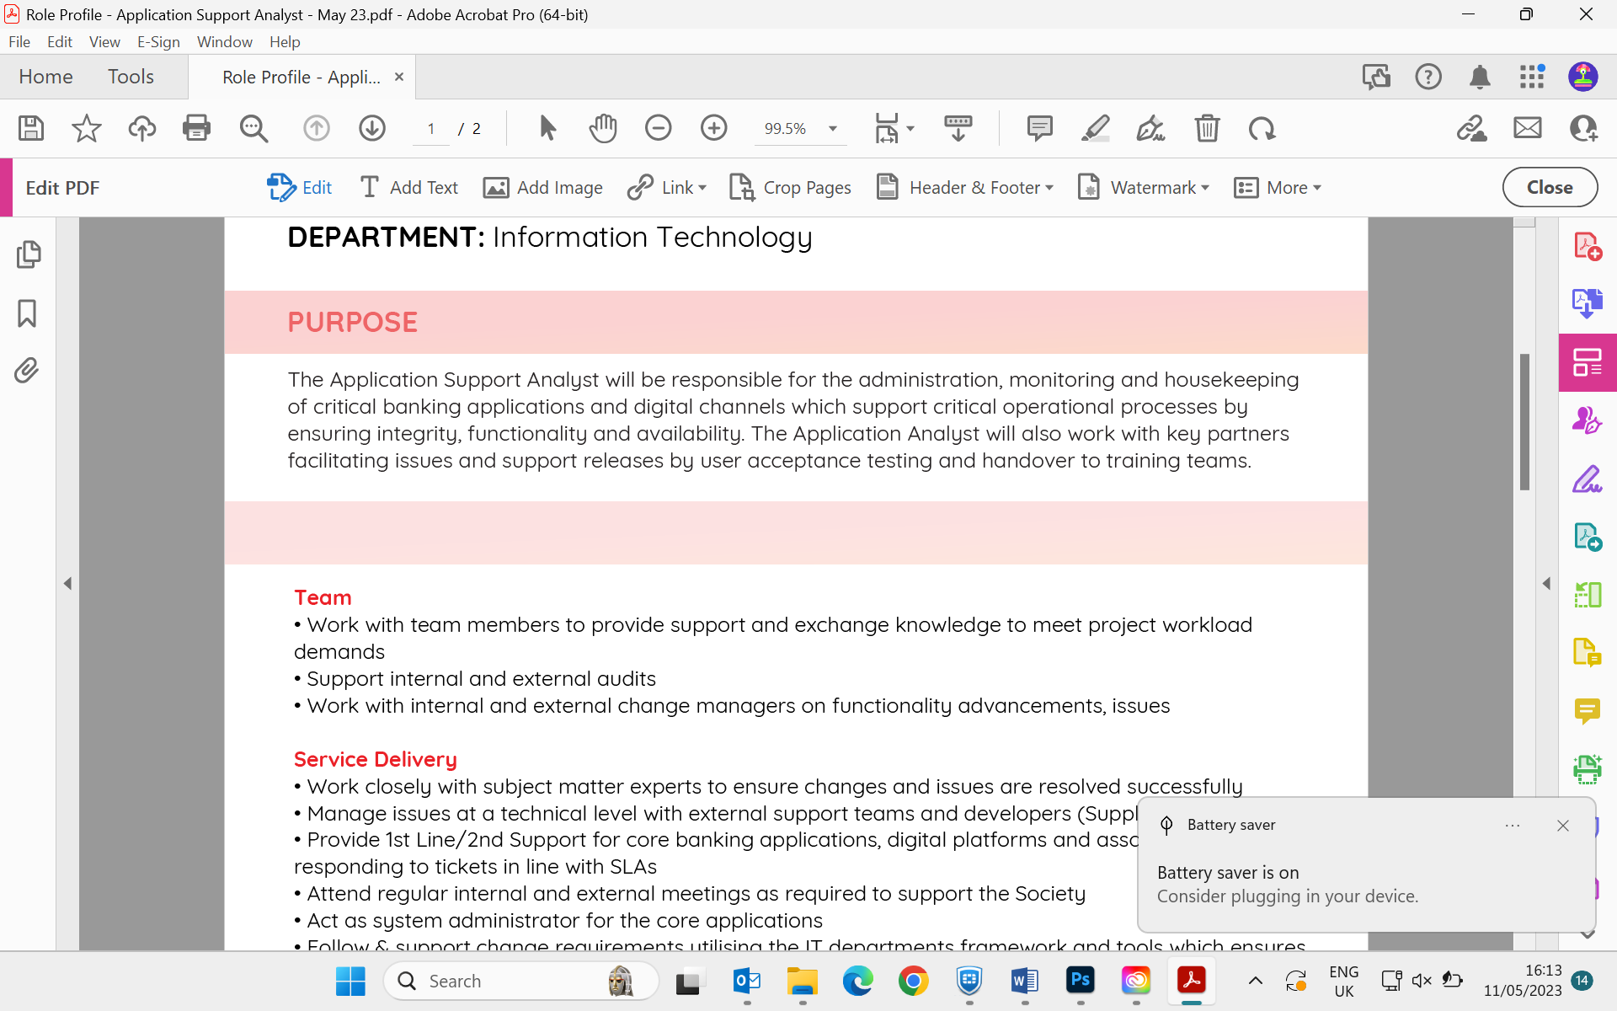
SCOPE
Team Management

- Leading and managing the Underwriting/Underwriting Support Team’s to deliver effective underwriting and customer outcomes with a solution based underwriting approach to support the Society’s growth plans
- Provide technical underwriting guidance to team members
- Ensure decisions within the department remain compliant with Lending Policy, credit risk appetite, and regulatory expectations in accordance with relevant MCOB rules.
- Ensure discretion afforded to underwriters is correctly utilized to provide responsible lending solutions within credit risk appetite
- Ensure underwriting of cases, post completion contract variations and review of case referrals are completed within SLA’s
- Ensuring the team are kept informed to changes to Lending Policy and wider processes which impact them
- Maintain relevant processes and procedures
- Effective team management, including creation and roll-out of annual PDRs, monthly, quarterly and annual 1-2-1s, quality control feedback, training and development, mandate recommendations, application decline review and confirmation, and Incident Reporting (Lets Fix It) action setting
- Completion of the teams quarterly T&Cs

Underwriting mandate
- Maintain a mandated position
- Underwrite mortgage applications regardless of amount focusing on the assessment of out of policy and more complex mortgage loans across a mix of residential lending types

Wider responsibilities
- Investigating and responding, where required, with requests relating to both internal and external audits to ensure their effective completion.
- Provide technical/regulatory support to BDM’s, Broker Support, Intermediaries, Internal Mortgage Advisors, Underwriters, Mortgage Servicing and the wider business
- Liaise with external partners and manage those relationships (such as LGSS, MIG, L&G, RSM UK, etc.).
- Proactively consider and where appropriate implement process and other improvements that optimise the effectiveness and efficiency of the Underwriting team
- Complete other tasks as required by the Chief Lending & Lending Officer

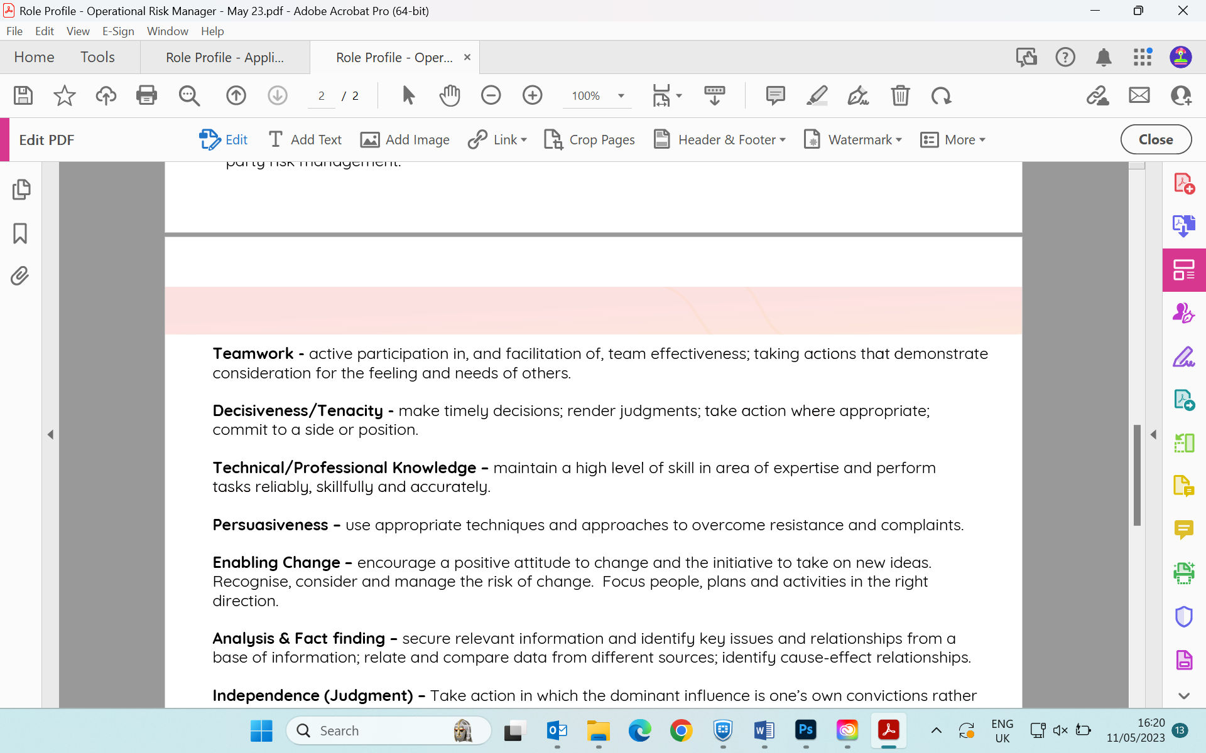
CORE COMPETENCIES
- Teamwork - Ability to work individually or as part of team. Active participation in team effectiveness; taking actions that demonstrate consideration for the feels and needs of others; being aware of the effect of one’s behaviour on others
- Planning & Organizing - Develops daily work plans from job objectives. Accurately prioritizes key tasks and avoids any negative impact of own actions or others
- Negotiation - Effectively exploring alternatives and solutions
- Initiative - Pro-actively obtains and uses necessary information to make informed decisions.
- Customer Service Orientation - Making efforts to listen to and understand the customer (both internal and external), anticipating customer needs, giving high priority to customer satisfaction
- Attention to Detail - Ensures that work is accurate and stands up to a high level of scrutiny. Presents oral and written communication succinctly clearing showing the proposal/recommendation
- Integrity - Consistency of actions, values and methods & principles
- Enabling Change - Encourages a positive attitude to change and the initiative to take on new ideas. Recognises and considers the risk of change.
- Focuses plans and activities in the right direction. Adopts a flexible approach in the work environment
KNOWLEDGE/SKILL/EXPERIENCE
Essential
- Experience of managing teams and developing staff working on own initiative
- Experience of manually underwriting both standard and (Specialist (Complex) areas of lending where discretion has been afforded
- Understanding of credit risk
- Understanding of individual and company accounts for the purpose of understanding the sustainability of current or potential income
- Understanding of Property Risk
- Analytical, thorough and able to interpret and communicate personal financial information in a practical way
- Clear communicator with a history of liaising with Intermediaries/BDM’s, Credit Committee and the wider business
- Ability to train and support colleagues with Specialist application assessments, documenting and tracking progress and ongoing development
- Ensuring the delivery of an effective underwriting team utilising the skills of new and experienced manual underwriters.
- Ensure applications are underwritten competently and within risk appetite
- Ensure submitted applications are processed to an acceptable level and within SLA’s
- Ensure servicing sales referrals are completed to an acceptable level and with acceptable timeframes
- Ensuring the work completed within the department meets regulatory and internal compliance requirements.
- Look to identify and deliver operational efficiency whilst maintaining acceptable levels of control/oversight
- Keeping up to date with, and maintaining a knowledge of, credit risk and regulatory rules/guidance connected with the assessment of mortgage applications
- Keeping all policy and supporting literature up to date.

ACCOUNTABILITIES

Desirable

- Completion of case review/T&C of underwriters
- Maintaining Policies and procedures
- Working knowledge of MCOB and other regulation.

